**Exercise 1:Let us consider data sampled from a univariate normal pdf wihe a mean $μ$ and known $δ$,where the prior of $μ$ is a normal pdf.**

1. **By using an existing source code, generate the data D from a normal pdf with**

$μ=0$**and $δ=1$**

1. **Plot the histogram from D.**
2. **Plot the likelihood, the prior and the posterior as a funtion of $μ$.**
3. **Compare these three functons.**
4. **Show analytically that the posterior is a normal pdf.**

**%1.Data D from a normal pdf with miu=0 and sigmod=1.**

num=500;

D=normrnd(0,1,num,1);

**%2.plot histogram from D**

figure

hist(D,25); 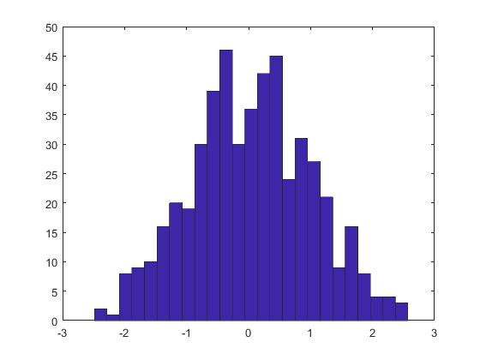

**%3.plot likelihood, prior, posterior**

u=[-1:0.01:1];

**%likelihood**

likelihood=prod(normpdf(D,u,1));

figure

plot(u,likelihood);

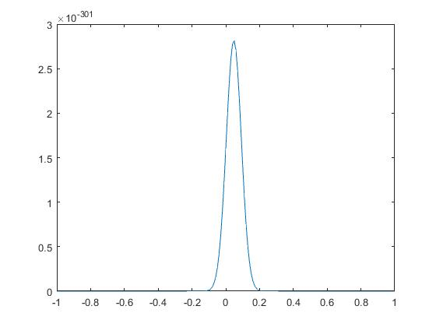

**%prior**

prior=normpdf(u,0,1);

figure

plot(u,prior);

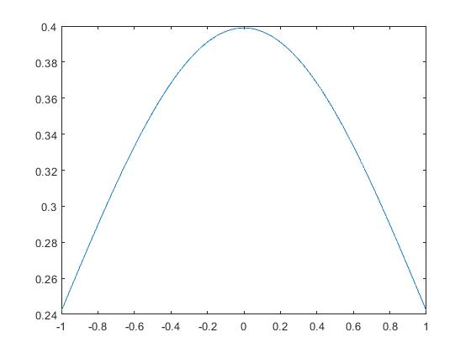

**%poster**

poster=prod(normpdf(D,u,1)).*prior;

figure

plot(u,poster);

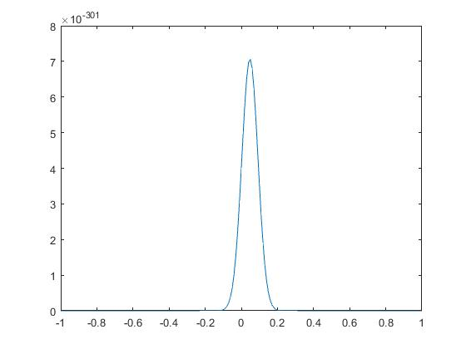

4&5. We hypothesis the prior is $p\left(μ\right)=N(μ|μ_{0},δ_{0}^{2})$,then,

we get the poster is $p\left(μ | X\right)=N(μ|μ_{N},δ_{N}^{2})$,

$μ_{N}=\frac{δ^{2}}{Nδ_{0}^{2}+δ^{2}}μ_{0}+\frac{Nδ_{0}^{2}}{Nδ_{0}^{2}+δ^{2}}μ_{ML}$, $\frac{1}{δ_{N}^{2}}=\frac{1}{δ_{0}^{2}}+\frac{N}{δ^{2}}$, ${ μ}_{ML}=\frac{1}{N}\sum_{n=1}^{N}{x_{n}}$

**Exercise 2: You need to read and understand the conditional expection**

**1. Explain in your own words the conditonal expection**

**2. Find g(x), g(x|y), E(X) and E(X|Y), where g(x,y) is a bivariate normal pdf having a**

**full covariance matrix.**

**3. Consider the roll of a fair die and let X=1 if the number is even and X=0**

**otherwise. Furthermore ,let Y=1 if the number is prime and Y=0 otherwise.**

1. **Find E(X), E(Y), and E(X|Y).**
2. **Consider that X and Y are independent variables, and Z=X+Y.**

**Find E(Z|Y)**

1. Conditional expectations, also known as conditional mathematical expectations. For convenience, we discuss two random variables X and Y, assuming that they have a density function f(x, y) and a conditional density function of Y under the condition of known X = x with g(y|x) , the edge density function of X is denoted by h(x). Defined under the condition of X=x, the conditional expectation of Y is defined as: E(Y|X=x)=∫y*g(y|x)dy.

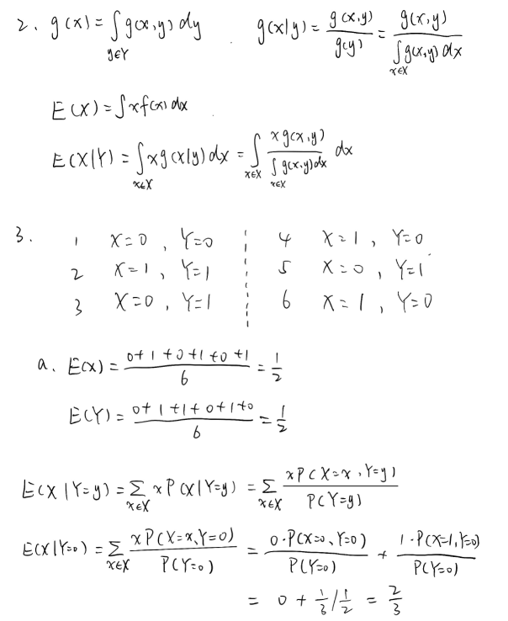

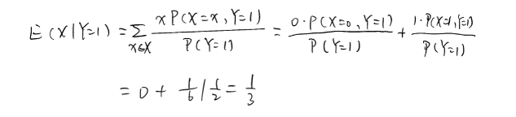

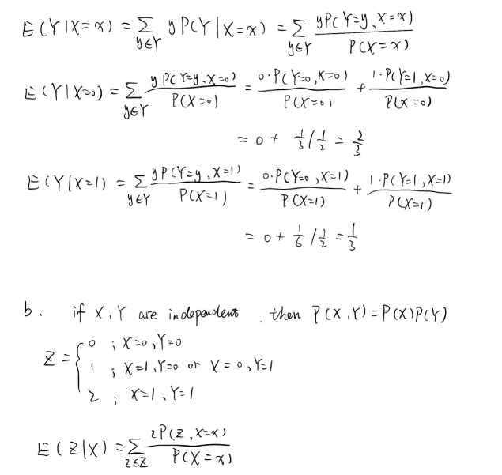

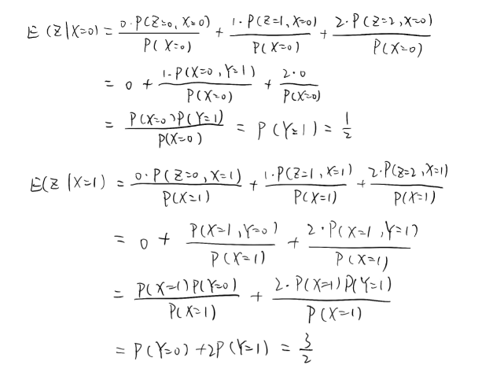

**Exercise 3:**

1. **Explain in you own words the generative and supervised learning.**
2. **Give an example.**

1.Generative learning:

The learning process refers to the process in which the learner's original cognitive structure interacts with the sensory information accepted in the public environment and actively constructs the meaning of the information. On the one hand, the model insists that the generation function is a basic cognitive process in understanding, and on the other hand insists that the human brain does not passively learn and record the input information, but actively process the input information and construct the meaning of information by combining the previous experience.

Supervised learning:

Supervised learning is a method in machine learning that infers unknown results from a known set of training sets. In supervised learning, each instance contains an input object and a desired output value. Supervised learning infers the expected output values of other input objects by analyzing the training data.

1. Examples:

Generative learning: For example, we look at a small animal far from the side of the road. You want to judge whether it is a dog or a deer. However, the distance is too far, and according to what you can observe now, it may be consistent with the characteristics of both. If you want to make a judgment at this time, I think most people will think that the animal that appears on the side of the road is a dog. why? Because dogs are more common in cities, the value of the prior probability p(y=dog) is greater. In this process, we use both the conditional probability and the prior probability to make judgments.

Supervised learning: Suppose we have a dataset that gives the relationship between the size of the house and the price of the house, so that we have to use a learning algorithm based on the training set we gave above to get a hypothesis function that makes this hypothesis function fit better. The data we give, so that we can better predict the price of the house when we give the size of the house in the future.

By 苏智龙 陈宏宇 余小新